Research on the LED Thermal dependence and effects in goniophotometer measurement
1st Jianping Wang¹, 2nd Xiaofeng Rao¹, 3rd Yongjun Luo², 4th Xiangping Ye³
¹ SENSING Instruments Co.,Ltd, Hangzhou, Zhejiang, China.
² Zhejiang University, Hangzhou, Zhejiang, China.
³ Huizhou Quality & Measuring Supervision Testing Institute, Huizhou, Guangdong, China.
Email: rd@sensingm.com
Abstract
The thermal dependence of LED is one of the important factors in the photometric measurement. However, the light output with temperature variation of tested sample during the measurement process is not a major factor for most LED luminaires in the mirror goniophotometers, comparing the effects of the mirrors. In this article, the experiments are carried out for this topic. More importantly, we analyze the uncertain factors of the measurement in the mirror goniophotometers.
Keywords: thermal dependence, goniophotometers, measurement
1 General
The uncertainties of LED measurement in the mirror goniophotometers are generally concerned by the photometric system，spatial angle, stray light, temperature effects, mirror flatness and polarization etc. The measurement uncertainty of the photometric system can be controlled within 3.5% mostly. The angle accuracy of 0.1 degree in spatial rotation mechanism can be implemented in γ angle and C plane. Considering the stray light effect, the installation of several apertures between the tested source and the photometric head is important to reduce the stray light in the measurement. However different types of the mirror goniophotometers will be provided with uncertainty difference in dependence of detecting beam geometry.
The temperature of high power LED is generally referred to junction temperature, ambient temperature, and the temperature on the heat sink and case. The light output will be affected in different ways, but most sensitive to junction temperature and relative less sensitive to ambient temperature. The experiment showed that the light output sensitivity of LED lamps to ambient temperature is 20 times less than to the heat sink^{[1]}. In the rotating mirror goniophotometers, the temperature variation risen by the air movement is a concerned issue.
In order to reduce the variation of light output of tested lamps and luminaires to temperature, especially fluorescent lamp tubes, it is indicated as “air movement in the vicinity of the luminaire should not exceed 0.2m/s” ^{[2]} in CIE 121 for goniophotometer of luminaries.
However, in lighting industry two typical geometries of mirror goniophotometers, both of center rotating mirror goniophotometer and round moving mirror goniophotometer are proposed in CIE 121 publication, the advantage of the former is in the constant detecting beam pass for convenient arrangement of diaphragm to eliminate stray light, and the advantage of the latter is in the fixed installation of tested luminaires for low effect of air flow in surrounding.
2 Disscussions
Currently, there are mainly four types of goniophotometer in the industry, including goniophotometer with center rotating mirror, goniophotometer with round moving mirror, goniophotometer with round moving mirror and detectors, and goniophotometer with rotating lamp.
First, In order to study the airflow speed caused by the movement of the mirror and tested lamp, we designed the experiments of mirror goniophotometers. These types of goniophotometers are set to low speed, medium speed and high speed rotation in the measuring state. The anemometer located at 10mm away from the surface of tested sample to measure the ambient airflow speed at different running speed of the system. The measurement data is shown in Table 1.
Table 1-Airflow speed at different running speed
Running speed  Airflow speed  Goniophotometer type | Low speed  (0.00776 rad/s) |  | Medium speed  (0.2244 rad/s) |  | High speed  (0.4188 rad/s)
Running speed  Airflow speed  Goniophotometer type | Min  （m/s） | Max  （m/s） | Min  （m/s） | Max  （m/s） | Min  （m/s） | Max  （m/s）
center rotating mirror | 0.02 | 0.04 | 0.03 | 0.07 | 0.04 | 0.1
round moving mirror | 0.03 | 0.05 | 0.04 | 0.08 | 0.05 | 0.11
round moving mirror  and detectors | 0.03 | 0.07 | 0.05 | 0.10 | 0.05 | 0.13
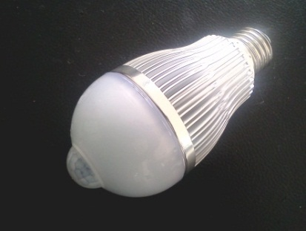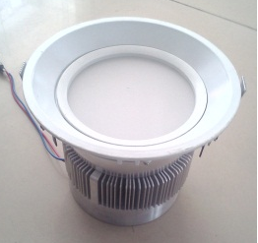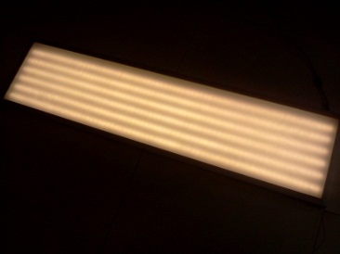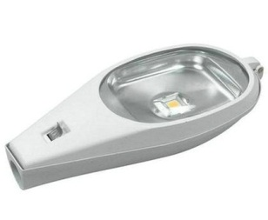
Bulb Down light Panel light Street light
Figure 1-Tested samples
Second, when LED is lighting, the temperature of different parts of LEDs are distinct. Through experiments, we study the sensitivity of different types of LED lamps for varying airflow and the resulting changes in the light output. We choose several typical LED samples, such as bulb, down light, panel light and street light(Figure 1), to be the tested sample. The goniophotometer with center rotating mirror are set in the state of high-speed, and a four-channels of temperature meter by wireless data communication is used to temperature measurement at three intended points on the heat sink, shell and case of the LED luminaire and a remote luxmeter is used to luminous flux measurement which be set 10mm away from the surface of tested sample(Figure 2). The ambient temperature of test laboratory is constant at 25℃ without additional air movement in the room.
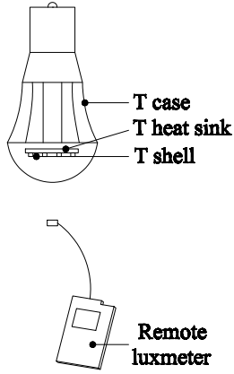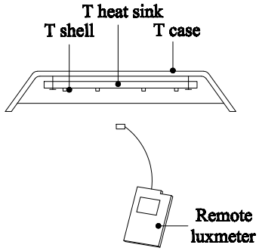
Bulb Down light
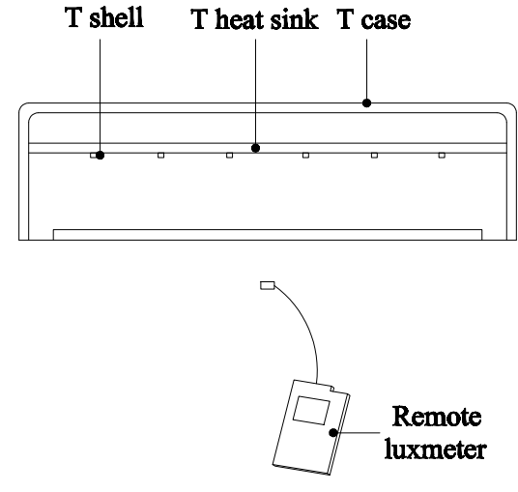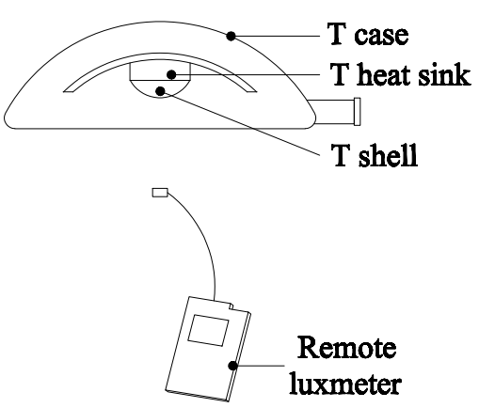
Panel light Street light
Figure 2-Test points
Third, the tested sample follows the mirror rotating when measurement. So the sample have several azimuth. Because of temperature is different at different direction, we research the relationship between direction, temperature and light output. We choose four typical direction(0°,90°,180°, 270°), and use four-channels of temperature meter and remote luxmeter to measure temperature and luminous flux.
3 Results
By the first experiment, the experimental data from Table1. The airflow caused by the movement of the mirror and tested lamp of three goniophotometries is different. Relatively, airflow of "center rotating mirror" is minimum and "round moving mirror and detectors" is maximum, the maximum speed of air movement is about 0.13m/s with highest running speed. However, they were all no more than 0.2m/s which is indicated by CIE121.
Form the second experiment, we draw a curve(Figure 3)according to the experimental data. The horizontal axis is the test points and the vertical axis is the numerical. We uniformly set 30 test points within the range of 360° of the γ-axis(every 12° is a test point). At different types of LEDs, the airflow for the influence of temperature is distinct. For the similar type of LEDs, airflow will greater affect temperature of heat sink and shell than case. For different types of LEDs, airflow will greater affect temperature of panel light and street light than other types. Overall, no matter what kind of LEDs, the impact of the airflow to light output are all very small. Following the maximum error of light output, the bulb is 0.44%, down light is 1.54%, panel light is 2.06% and street light is 2.37%. It is accepted for most industrial applications. For other goniophotometers with round moving mirror, air movement is detected while the mirror running with high speed, especially for goniophotometer with round moving mirror and detectors. The effect of airflow produced by running mirror and detector setup is dependent on the running speed, arm length and section area in circle cross.

Bulb Downlight

Panel light Street light
Figure 3- Relationship between temperature and light output
For the third experiment, we get the relationship between direction, temperature and light output(Table 2). In this experiment, we only study the temperature differences caused by spatial uniformity of temperature of test laboratory because we choose four specific positions. From table 2, the temperature of heat sink, shell, case and ambient is change at different degree from 0° to 270°. In contrast, temperature of heat sink is more susceptible than others. However, light output is only slight differences which is acceptable for the vast majority of industrial applications. In order to keep ambient temperature of test laboratory is constant at 25℃, we usually use air conditioning from upper or bottom cooling/heating. So the spatial uniformity of temperature of test laboratory usually caused by use of air conditioning. We can be reasonable to use the air conditioning to improve the spatial uniformity of temperature.

Table 2-Relationship between direction, temperature and light output
Sample | Direction  (°) | Temperature |  |  |  | luminous flux(lm)
Sample | Direction  (°) | T_{heat sink}(℃) | T_{shell}(℃) | T_{case}(℃) | T_{ambient}(℃) | luminous flux(lm)
Bulb | 0 | 55.1 | 31.3 | 25.2 | 25.1 | 4043
Bulb | 90 | 55.3 | 31.4 | 25.5 | 25.3 | 4039
Bulb | 180 | 55.7 | 31.7 | 25.9 | 25.7 | 4022
Bulb | 270 | 55.4 | 31.5 | 25.6 | 25.5 | 4036
Down light | 0 | 58.1 | 44.5 | 25.5 | 25.4 | 4338
Down light | 90 | 58.4 | 44.5 | 25.9 | 25.4 | 4319
Down light | 180 | 58.9 | 44.8 | 26.1 | 26.0 | 4300
Down light | 270 | 58.6 | 44.6 | 25.8 | 25.6 | 4315
Panel light | 0 | 63.2 | 47.6 | 25.8 | 25.3 | 4840
Panel light | 90 | 63.6 | 47.5 | 26.5 | 25.7 | 4819
Panel light | 180 | 64.4 | 48.7 | 26.9 | 26.1 | 4799
Panel light | 270 | 63.9 | 47.9 | 26.7 | 25.9 | 4815
Street light | 0 | 68.1 | 47.4 | 25.6 | 25.3 | 10840
Street light | 90 | 68.9 | 47.8 | 26.4 | 25.5 | 10809
Street light | 180 | 69.5 | 48.2 | 27.2 | 26.3 | 10765
Street light | 270 | 69.1 | 48.0 | 26.8 | 25.8 | 10800
4 Conclusions

From above experiment results, the influence of temperature on the light output is less than 3%. So it is not the most important factor in the photometric measurement. However, ES BN13032 made a specific provision for the flatness of mirror, it is indicated as “the standard deviation of the readings expressed as a percentage of the mean shall not be greater than 1.5% and each reading shall not differ by more than 5% from the mean”^{[3]}. In fact, the current mirror system used by many goniophotometer can not reach this accuracy. And some dual-mirror goniophotometers(rotating mirror and fixed mirror)exist a larger system measurement error. Moreover, the error is difficult to be corrected in the measurement results. There are many defects in existing dual-mirror goniophotometer, so the correction method of the dual-mirror goniophotometer has not been widely recognized in the industry.
In summary, it is exaggerated the impact of the airflow and wind speed in light output, while ignoring the major factors that affect the measurement results, especially the flatness of the mirror and the number of the mirror. There are large number of specific experimental data in this article, and effective illustrates the airflow and wind speed of several goniophotometer for the measurement results with minimal impact. We should pay more attention to flatness of mirror, rather than the airflow of the goniophotometer.
References
[1] Zong Yuqin, 2009, Luminous flux and color measurement of high-power LEDs, CORM 2009 Annual Conference and Business Meeting, Workshop on Solid State Lighting Measurements and Standards, USA.
[2] CIE 1996. CIE 121: 1996, Integrating Sphere and Goniophotometer System. Vienna: CIE.
[3] BS EN 2004. BS EN 13032-1: 2004, Light and lighting — Measurement and presentation of photometric data of lamps and luminaires —Part 1: Measurement and file format. Brussels: CEN.

